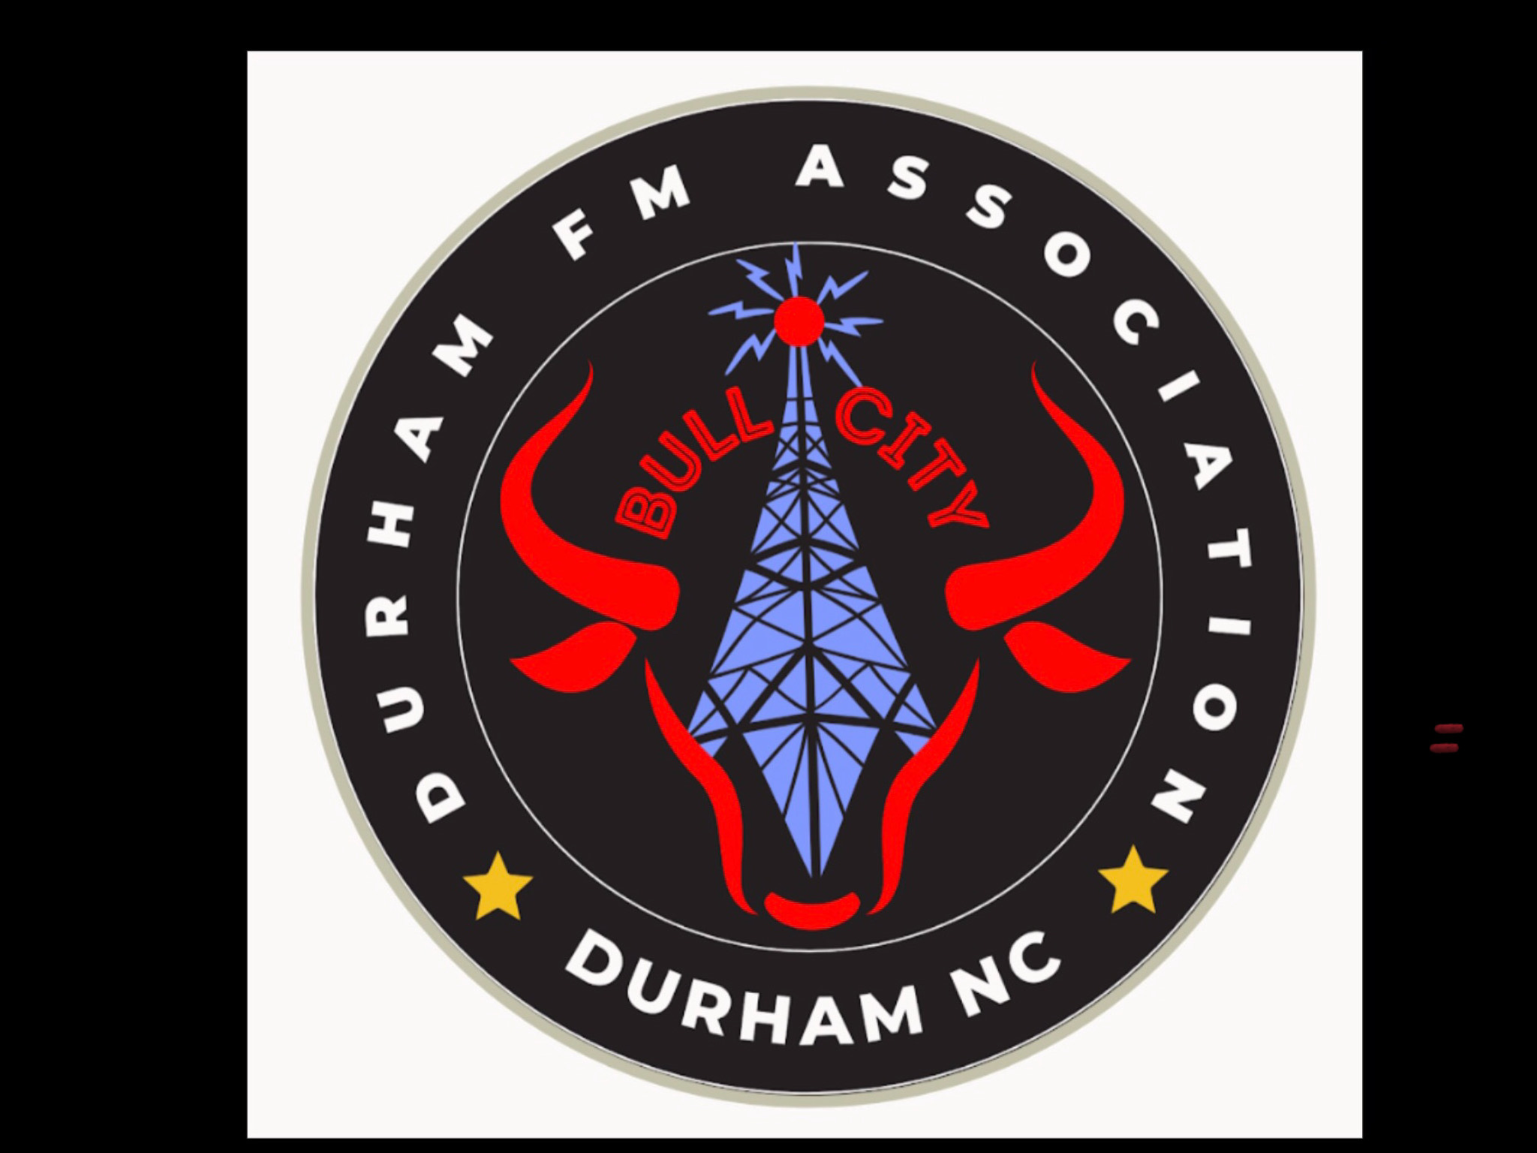
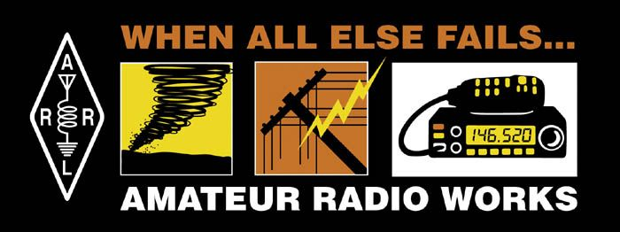

Secretary- David Warwick K4DJW

Members Present:

NAME CALL SIGN POSITION

1. Beckett, Tom KR3BTP Treasurer
2. Berzinskas, Bill WW1H
3. Berzinskas, Daniel KQ4GOB
4. Boone, John KM4MDR
5. Cherry, James N4CHR
6. Connelly, Pat KO4QLU
7. Cook, Bob W4FK President
8. Demas, Ted KQ4AAP
9. Ding, Allison KO6OTP
10. Dries, Ev KR4OQR
11. Durst, Charlie NC4CD Repeater Manager
12. Eddleman, Dan KR4UB
13. Garbutt, Quincy KR4JEZ
14. Howell, Janice KQ4ZGL
15. Lamb, Wilson W4BOH
16. Robertson, Paul N2XZF
17. Schiffman, Susan KR4LGG New Member
18. Schnoes, Paul NOUS
19. Snyder, Dave W4SAR
20. Snyder, Karen KD4YJZ
21. Stafford, Matthew KQ4ZYW Vice President
22. Staten, Sienna KF0VXQ
23. Tannous, Sam KJ4VWG
24. Tiulchievyl?, Michael N/A
25. Warwick, Dave K4DJW Secretary/EmCom

1) Bob Cook (President) opened the meeting and asked if there was any news to discuss.

2) Dave Warwick (Secretary) stated that Winter Field Day will be held at Little River Regional Park on 23 January 2027. Plenty of room for antennas and radios.

3) Charlie Durst (Repeater Manager) talked about the clubs storage shed, clean out date is 09:00, 21 Nov. If anyone wants anything they need to show up on the clean out date otherwise it is all going to the dump. Charlie repaired the 147.225 repeater power connector that got too hot and melted. The repeater is working fine now. Charlie set up a meeting with Durham County Emergency Management for tomorrow 4 Nov. to discuss the DFMA Pace Plan. Charlie donated several books and magazines that are on the back table and are free to anyone who wants them.

4) Tom Beckett (Treasurer) said the Clubs safety deposit box still has not been opened by the bank but he will let us know when that happens.

5) Wilson Lamb also donated several books and various electronic items that are on the back table free to anyone who would like them.

6) Bill Berzinskas gave an informative program about the clubs website. He mentioned that Events like club meetings, hamfests and POTA can be listed on the website. He also said that club members status; call sign expiration, dues and other data is automatically updated. Bill covered a lot of information about the website and requested that everyone take a look at the website and provide him feedback on what you like, don’t like, and any suggestions you may have to improve it.

https://dfma.org/wp-admin/admin.php?page=rct-meetings

